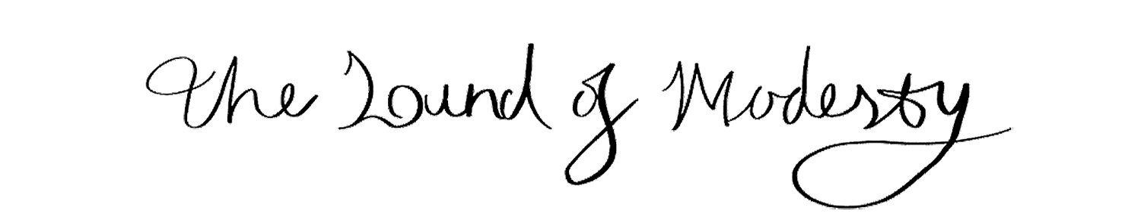
FOR RELEASE 6TH NOVEMBER 2020

The Sound of Modesty Releases Her Terrifying New Rock Ballad ‘As All Things Should Be’
---------------------------
Leeds based experimental alternative rock artist The Sound Of Modesty is excited to announce the release of her 4th single ‘As All Things Should Be’ which will be available worldwide on 6th November. This time singing about the dangerously delicate relationship a girl has with her abusive mother; the track is bursting with energetic drum fills, screeching guitars riffs and hair raising vocals that are sure to get your blood pumping!

The accompanying music video, directed by film graduate and horror enthusiast Catherine Jabolinski, will be released on the weekend of its release.
---------------------------
In addition, The Sound Of Modesty has two previous tracks - Stalemate and Warm Floors/Cold Bodies - which will feature alongside As All Things Should Be on an album to be released in 2021.

Take a listen to Stalemate and Warm Floors/Cold Bodies here - https://open.spotify.com/artist/2IEXrLzfBRtmeo4XKRxEVd?si=dtzlfA3OTwGQmrnDnOoY1Q

Her new website has also recently been published, where you can find all the relevant information. Take a look at this location - https://thesoundofmodesty.com
---------------------------
London Singer-songwriter Yvonne Han started creating as ‘The Sound of Modesty’ in 2018. Known for both her candid lyrics and unique take on alternative rock, she continuously blends narrative, avant-garde and modernist metal elements in her music.

After being in an alt-indie band Once A Week Won’t Kill You featuring on drums, Yvonne had started developing her own exclusive songwriting style, influenced strongly by not only experimental female artists like Mitski and Bjork, but also electronic pop artists like Egoist and T.a.T.u, and furthermore crossing over with softer pop such as Sleeping At Last and Regina Spektor.

She went on to independently release her debut EP; Eye, The Cauldron of Morning (2018).

More recent projects include the self-release: Metamorphosize under Wuthering Records in February of 2020. Yvonne currently studies Production and Songwriting at Leeds Conservatoire and is currently finishing off her debut album alongside her band for release in 2021.
---------------------------
Contact information
Please get in touch with Yvonne at thesoundofmodesty@gmail.com for bookings, interviews, guest list or any other matters of relevance.

Social Media Links:
Website: https://thesoundofmodesty.com/home
Facebook: https://www.facebook.com/thesoundofmodesty
Instagram: https://www.instagram.com/thesoundofmodesty

